EXPT NO:03
EDA-DATA INSPECTION AND ANALYSIS
AIM:
To inspect and analyze the Driver Standings dataset using Exploratory Data Analysis (EDA) by examining its structure, statistical characteristics, missing values, and by filtering driver standings based on points and finishing position.
ALGORITHM
PROCEDURE:
1. Start the program.
2. Import the required libraries Pandas, NumPy, and Matplotlib.
3. Load the Driver Standings dataset using Pandas.
4. Display the first five and last two records.
5. Display the shape, column names, data types, and dataset information.
6. Generate the statistical summary of numerical attributes.
7. Check for missing values in the dataset.
8. Create a DataFrame containing important Driver Standings attributes such as driver standings ID, race ID, driver ID, points, position, position text, and wins.
9. Filter driver standings having more than 100 points.
10. Filter driver standings with a finishing position of 1.
11. Display the filtered results.
12. Generate suitable charts for points and finishing-position distributions.
13. Interpret the obtained results.
14. End the program.

CODE:
import pandas as pd
import numpy as np
import matplotlib.pyplot as plt

# Load Dataset
file_path = "driver_standings(1).csv"
df = pd.read_csv(file_path, low_memory=False)

# Select Important Columns
standings_df = pd.DataFrame({
"DriverStandingsId": df["driverStandingsId"],
"RaceId": df["raceId"],
"DriverId": df["driverId"],
"Points": df["points"],
"Position": df["position"],
"PositionText": df["positionText"],
"Wins": df["wins"]
})
print("Original DataFrame:")
display(standings_df.head(5))
print("\n1. First 5 rows:")
display(standings_df.head())
print("\n2. Last 2 rows:")
display(standings_df.tail(2))
print("\n3. Shape:")
print(standings_df.shape)
print("\n4. Column Names:")
print(standings_df.columns)
print("\n5. Data Types:")
print(standings_df.dtypes)
print("\n6. Statistical Summary:")
display(standings_df.describe())
print("\n7. Missing Values:")
display(standings_df.isnull().sum())
print("\n8. Driver standings with more than 100 points:")
high_points = standings_df[standings_df["Points"] > 100][["DriverId","Points","Position","Wins"]].head(10)
display(high_points)

print("\n9. First-position standings:")
first_position = standings_df[standings_df["Position"] == 1][["DriverId","Points","Position","Wins"]].head(10)
display(first_position)
# 10. Visualization - Points
points_all = standings_df.dropna(subset=["Points"])
plt.figure(figsize=(10, 5))
plt.hist(points_all["Points"], bins=20)
plt.title("Points Distribution")
plt.xlabel("Points")
plt.ylabel("Number of Standings Records")
plt.tight_layout()
plt.show()
# 11. Position Distribution
position_counts = standings_df["Position"].value_counts().sort_index().head(15)
plt.figure(figsize=(10, 5))
plt.bar(position_counts.index.astype(str), position_counts.values)
plt.title("Top Finishing Positions")
plt.xlabel("Finishing Position")
plt.ylabel("Number of Standings Records")
plt.tight_layout()
plt.show()
# 12. Wins Distribution
wins_counts = standings_df["Wins"].value_counts().sort_index().head(15)
plt.figure(figsize=(10, 5))
plt.bar(wins_counts.index.astype(str), wins_counts.values)
plt.title("Wins Distribution")
plt.xlabel("Wins")
plt.ylabel("Number of Standings Records")
plt.tight_layout()
plt.show()
# 13. Correlation Matrix
print("\n13. Correlation Matrix:")
display(standings_df.corr(numeric_only=True))
print("\nEDA inspection and filtering completed successfully.")

OUTPUT:
First 5 rows:
driverStandingsId | raceId | driverId | points | position | positionText | wins
1 | 18 | 1 | 10.0 | 1 | 1 | 1
2 | 18 | 2 | 8.0 | 2 | 2 | 0
3 | 18 | 3 | 6.0 | 3 | 3 | 0
4 | 18 | 4 | 5.0 | 4 | 4 | 0
5 | 18 | 5 | 4.0 | 5 | 5 | 0

OUTPUT:
Last 2 rows:
driverStandingsId | raceId | driverId | points | position | positionText | wins
73269 | 1144 | 859 | 4.0 | 21 | 21 | 0
73270 | 1144 | 862 | 0.0 | 24 | 24 | 0

OUTPUT:
Driver standings with more than 100 points:
driverId points position wins
4 103.0 2 4
8 110.0 1 6
4 109.0 3 4
4 108.0 1 6
30 106.0 2 6
4 108.0 1 6
30 116.0 1 7
4 116.0 2 6
30 116.0 2 7
4 126.0 1 7

OUTPUT:
First-position standings:
driverId points position wins
1 10.0 1 1
1 14.0 1 1
8 19.0 1 1
8 29.0 1 2
8 35.0 1 2
1 38.0 1 2
9 42.0 1 1
13 48.0 1 3
1 48.0 1 3
1 58.0 1 4

OUTPUT:
Outlier Detection : Points
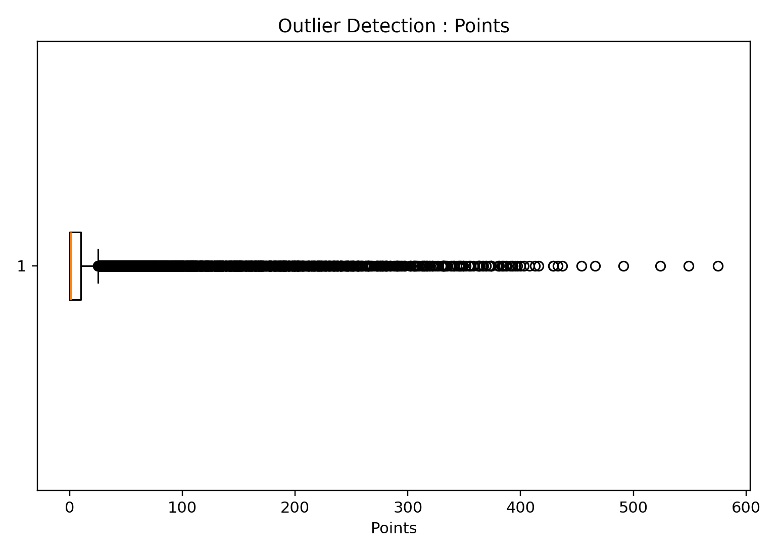
Outlier Detection : Position
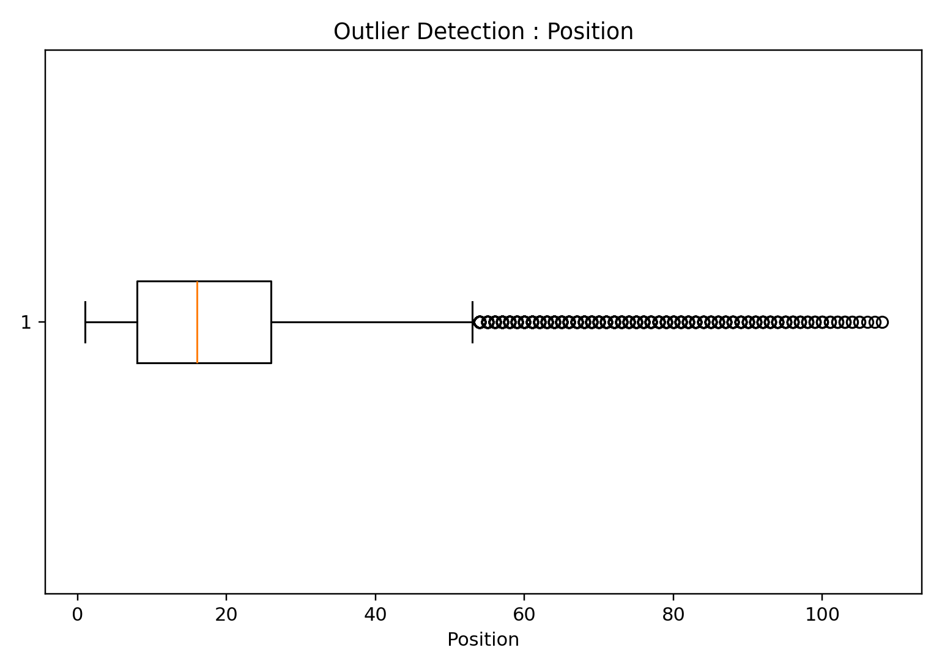

OUTPUT:
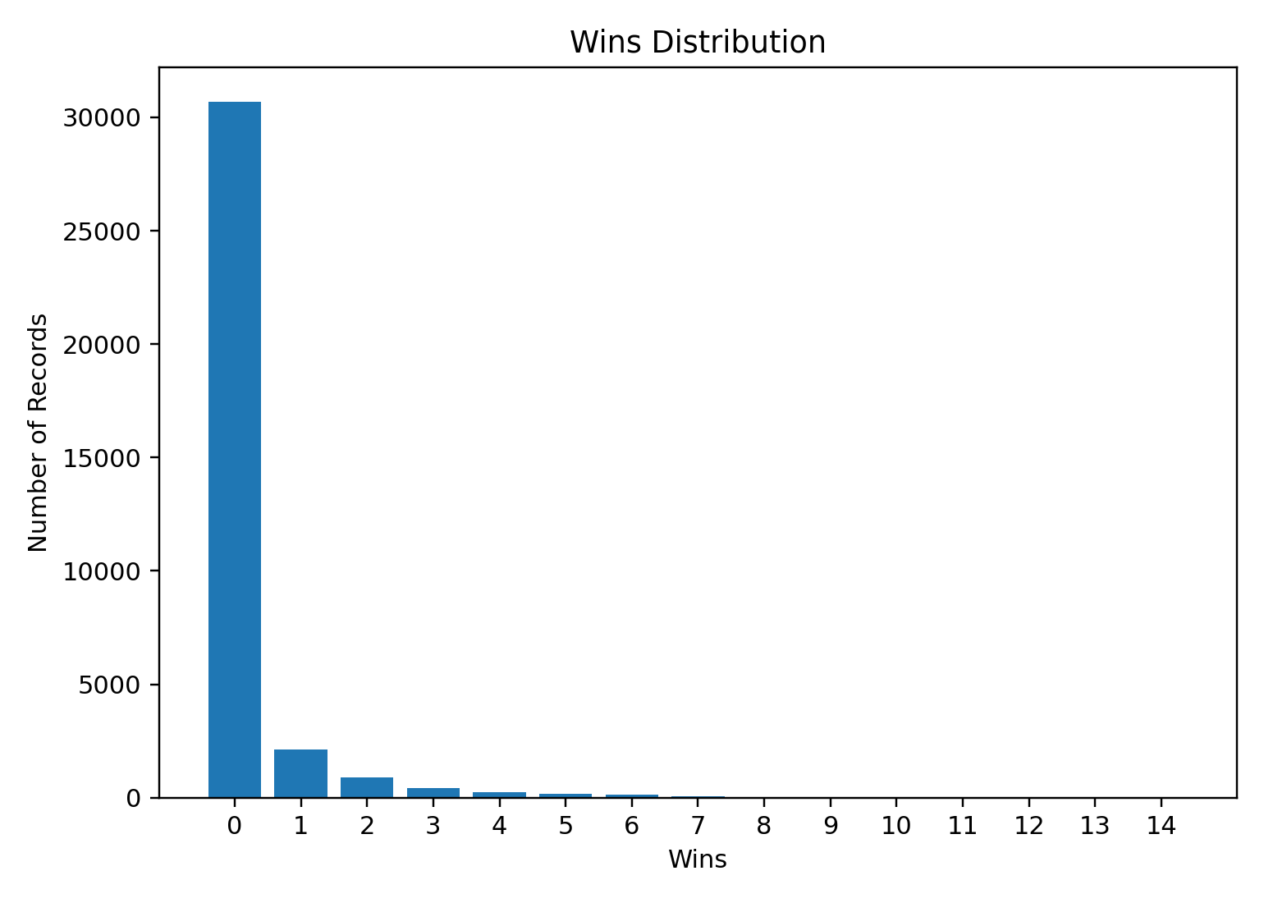
Result:
The Driver Standings dataset was successfully inspected and analyzed using Exploratory Data Analysis. The dataset structure, statistical characteristics, missing values, points, finishing positions, wins, and correlations were examined, and driver standings were filtered based on points and finishing position.

